Computational Complexity Issues

The main question of security, ‘What is a possible computation?’ derives from the consideration of security of cryptosystems against computational atttacks. In mathematics, this is called computational complexity theory. This section consists of the complexity issues along with discrete loagrithm problem.

“The discrete logarithm problem for the group G may be stated as:

Given g E (belongs to) G and a E (belongs to) (g), find an integer x such that g ^x =a.” (page 49 number 1)

The statement of the problem above is the primary aspect that needs to be considered. Firstly, there is logic to discuss the discrete logarithm problem in an arbitrary semigroup; however, in many cases the curiosity is in precise examples of finite cyclic groups.

The above statement has precisely eliminated that a may not be possibly within the cyclic group generated by g. There is another way to state the problem:

“Given a, g E (belongs to) G, determine if there exists an integer x such that g^x=a, and if so, find such an x.”

There could be more difficulty to solve this version of the problem. In order to resolve the discrete logarithm problem, analysing an algorithm could be utilised and therefore it would have an affect, as to go ahead with the analsis we should be aware that a E (belongs to) (g). From now on, the assumption will be made that the group G is cyclic, with G = (g), so the initial statement of the problem can be used.

The statement “given the group G” should be defined in an unambiguous way. There could be many abstract ways that groups could occur; the following gives a few examples:

- the imaginary quadratic field’s class group, which is received by the discriminant
- an elliptic curve over a finite field or rational numbers, where a group of points occur, received by the equation of the curve and the specification of the field
- Galois group of a polnomial
- Finite Abelian group which is received by invarian factors or generators and relations.

The following assumtions need to be made for the group G, which are as follows:

- We know efficient algorithms for testing equality of group elements
- We know an efficient algorithm for multipling any two elements of the group
- The group if finite, generated by g, with known order n. (page 52,53)

The classification of computational problems is the aim of the field of computational complexity whilst corresponding the level of difficulty. An example of a random polynomial time reduction between two computational issues is the discrete logarithm algorithm which could be used to determine the order of the base for the logarithm. This type of reduction can be seen as a partial ordering which is induced from the computational issues depending on the complexity dealt with, and valuable data could be given on the intrinsic complexity of the issue. In this particular situation, it could be hard to determine the discrete logarithms because it is initially used to determine the order of that base in the group.

Reduction

Firstly we have to consider a few simple methods which will decrease a discrete logarithm problem in a cyclic group G to discrete logarithm problems in different subgroups. In order to start it is essential to mention all the rules involved. It is not too difficult to multiply and take inverses in G, which is required in this case. There could be a problem in some cases where there could be a possibility that two elements could be equal, for example, suppose the group is viewed as a sructure with proportions, or there maybe a group of binary quadratic forms, however, an assumption should always be made while carrying out a group operation, that the cost of deciding if the two elements of G are equal is of the identical magnitude. Another assumption is that the group elements could have allocated symbols so that they could be kept.

The first reduction

Suppose the cyclic group G has the order n and n is factored significantly as n=u,v, u and v here are coprime, and thus gcd (u,v) =1. So now the issue of solving a discrete logarithm in G is decreased into solving for order u and v of the discrete logarithm in the subgroup of G. Specifically, if G = {g}, then g^u generates the subgroup of u-th powers in G, which has order v, and in the same way g^v generates the subgroup of v-th powers, which has order u. Solving the discrete logarithm l_u, l_v, where

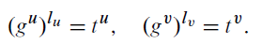

By performing repeated squaring you can solve the powers g^u, g^u, t^u, t^v. (Buhler and Wagon 2008)

Adopting the extended Euclidean algorithm may discover the integers a, b do au + bv =1. So
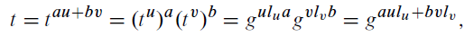

and we come to the conclusion for discrete logarithm of t is aul_u + bvl_v.

The next reduction

This reduction assumes that the order is a prime power of G, so for example, p^a, where a > 1. The discrete logarithm issue of order p in the cyclic subgroup of G, could have been reduced to a from the dicrete loagarithm in the group. Suppose we need to discover the l from g^l=t. In the base p, if we add in the l, where l is satisfied for a smallest positive value, then
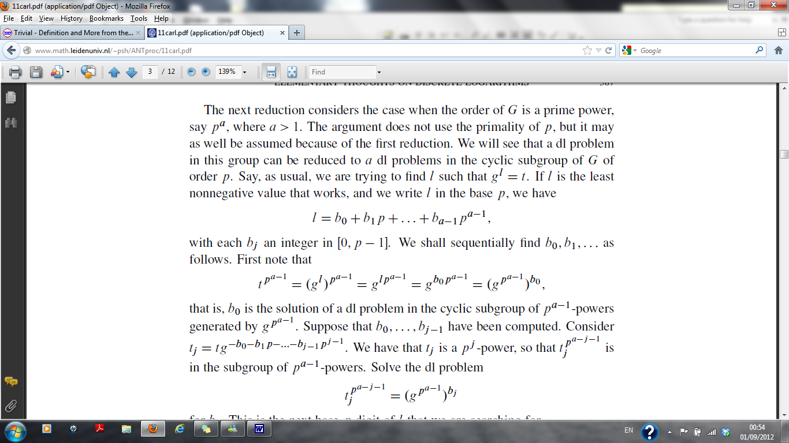

For each b_j being an integer in [0, p-1]. b_0, b_1….should be discovered in order. Consider the following

The p^a-1 powers which are generated by g^p^a-1 in the cyclic subgroup, b_0 is the resolution of the discrete logarithm problem. Assume the calculation for b_0…..b_j-1, has alread been done. Note that
.

it can be observed that t^j is a power of p^j, and therefore j_j^p^a-j-1 is in the grou with powers of p^a-1. The discrete loarithm issue for b_j needs to be solved.

we now need to look for the the base p digit of l.

To demonstrate such reduction, we need a help of an example. So consider an example where g=11, t=17 in (Z/101Z)*. It is sufficient to solve two discrete logarithm issues for every groups of order 2 and 5. it is sufficient because 100 is the order of the group. So 17^25 = (equivalent to) -1(mod 101), order 4 in the subgroup, the element 17^25 should have 2 as their discrete logarithm i.e. l_25=2. The two problems have now been solved for the order 2, the first one is 0 and the second on, therefore l_25=0+1.2=2).

We should now find l_4 for 11^l4 = 17^4 = 95(mod 101), the order of 25 is being solved for the discrete logarithm in a cyclic group. The discrete logarithm calculation had been decreased to two in a group of order 5. Firstly we have to calculate 17^20 = 95^5 = 1(mod 101), this concludes that l_4 is a multiple of 5. In addition, 11^20 = 87(mod 101). For the 95 modulo 101 we need to look for a power which corresponds to 87, and the solution is 0,1,2,3 or 4. it is obviously not 0 or 1 so we try 2 which works. So l_4 = 0+2.5=10. Next we consider (-6).4+1.25=25, therefore (-6).4.10+1.25.2=-190 is the discrete logarithm for 17. 10 is the smallest positive discrete logarithm.

We can now control the group order, however, this could not be the situation most of the time, we should decrease the problem to smaller situation as we have just seen above which could be done by running a factorisation algorithm on the order because some discrete algorithms are most of the time difficult in practice than factoring. Smaller situation could be easier, unless in some cases working on subgroups which could be just as hard as working in the full group.

Algorithms for the Discrete Logarithm Problem

When considering the calculation of discrete logarithms keeping in mind the rigouros proof of such behavior is important. this can be done by differentiating how the algorithms are created, for example whether its practical or sructured. Note that when calculating discrete logarithm over GF(2^k)*.

Algorithms for general groups

This part is dedicated to any omitted information regarding the group for the algorithms. To create the algorithm which is straigtforward and clear is the one that consist a table of every n powers along with g which is easy to find the group elements which is contained in the table and find the discrete logarithms. As a minimum, with n times you can calculate the table, and to store the table it will take O(n) space. The main aim of algorihms is to advance such limits.

This final catergory contains the calculus methods but these are not of great interest to us under the context of finite fields GF(2^n), and so this review will centralise on algorithms belonging to the first two catergories only.

Baby steps, giant steps

We are going to look at a group G={g} of order n and tE(belongs to) G. Consider 0_< l _< n-1 and g^l=t, the main aim here is to discover an integer l. We now have to restate the discrete logarithm l in the base m and assume m= [root n]. Thereafter, l = b_0 + b_1m where 0-<b_0, b_1-<m-1. Its suffice to discover b_0, b_1 and clearl discover l.

There are two lists that we need to arrange. The first one is 1,g…..,g^m-1 this is by taking ‘baby steps’ whilst the second one is t,tg^-m….,tg^-(m-1)m b taking ‘giant steps’. These two list should have general elements in them as g^b_0 =tg^-b_1m. t can be easily discovered straight away because the general elemnents helps us.

In order to discover

http://www.math.leidenuniv.nl/~psh/ANTproc/11carl.pdf (2)

http://www.mccurley.org/papers/dlog.pdf (1)

